Vlocity Upgrade Summer’21 Impact fix steps

**November 4, 2021**

**Version: 1.3**

Contents

[1] Remove additional Vlocity actions: 3

[2] To Change Display sequence of Vlocity actions: 7

**Vlocity Upgrade Impact Fix Steps:**

## [1] Remove additional Vlocity actions:

1. Open the dataloader and Click on **Export.**
2. Click on Login
3. Enter the Username and Password followed by verification.
4. After successful login, Click on Next.
5. Select the Object as “**Vlocity Action**” and click on browse to tag the extract file.

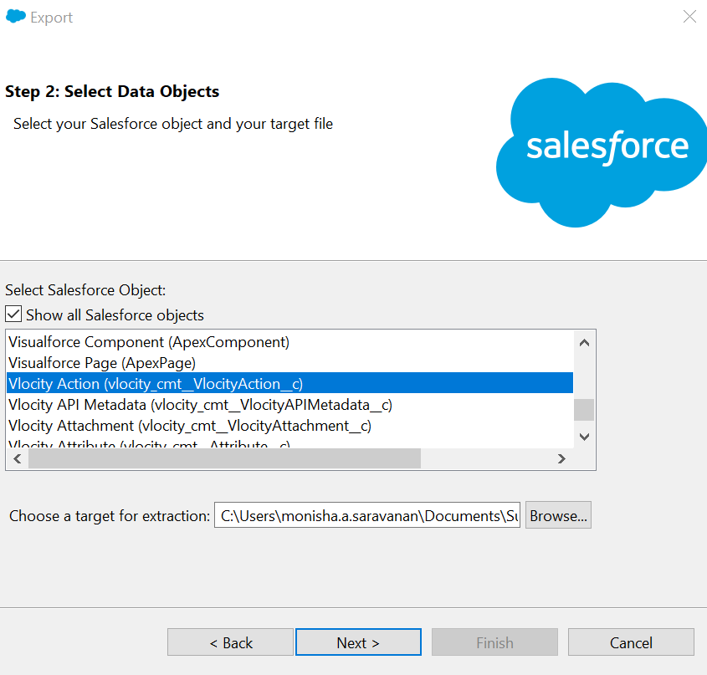

1. Type the following query to extract the additional vlocity actions:

Select id,name,vlocity_cmt__IsActive__c from vlocity_cmt__VlocityAction__c where name IN ('Edit Record','Generate Document PDF','New Order','Status Notifications','Cancel','Amend','Discard','Create Contract in Batch','Launch Multi-Site Order','Launch Multi-Site Quote','XOMExecuteCustomOmniscript','MultiServiceQuoteCheckout','Apply To Group V2','Create Order','Price And Validate','Amendment History','Create Assets','VerifyActionProcessService', 'Update Frame Agreement-Quote', 'Update Frame Agreement-Oppty', 'Create Frame Agreement-Quote', 'Create Frame Agreement-Oppty','Discount Approval', 'XOMExecuteCustomOmniscript')

1. Click on **Finish**.

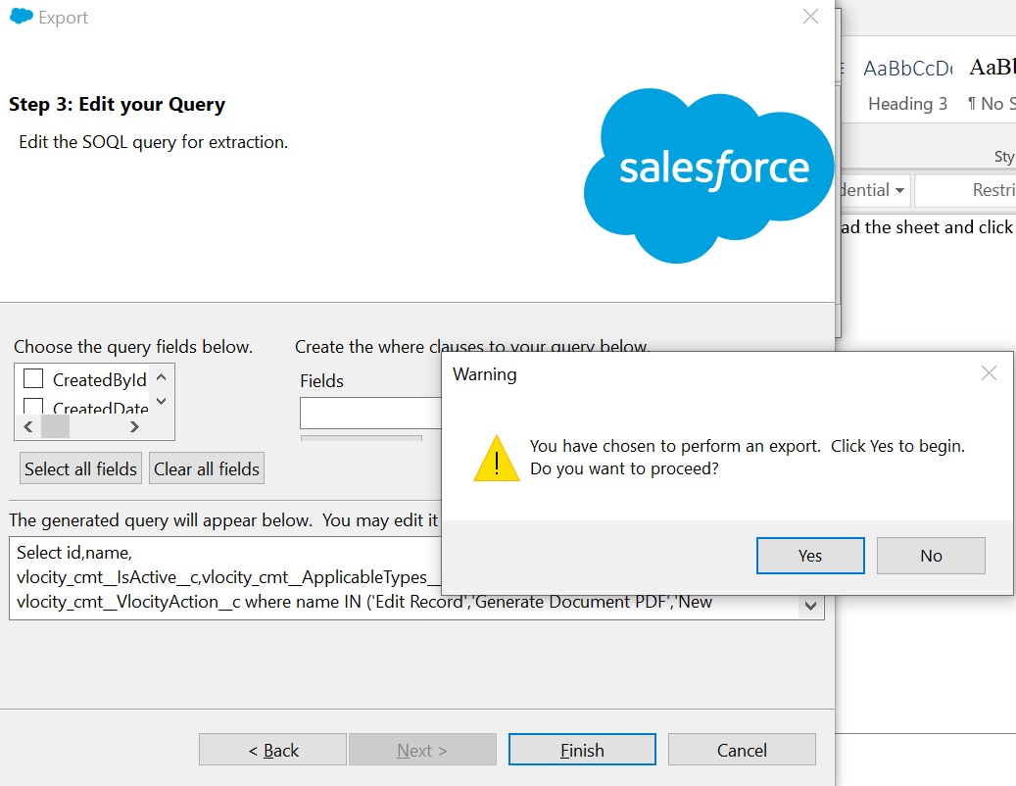

Records will get extracted.

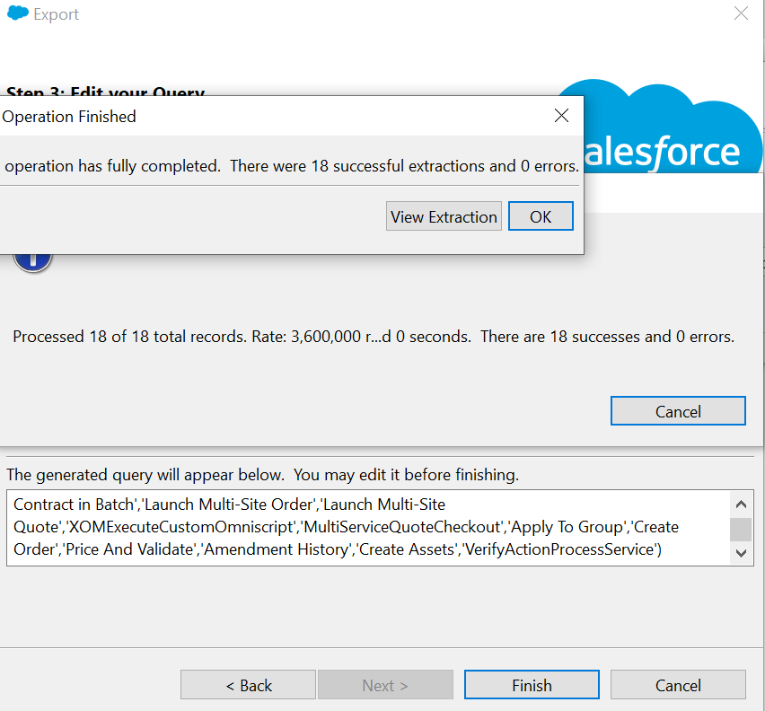

1. Open the Extract sheet and Update the “VLOCITY_CMT__ISACTIVE__C” field column value as “FALSE” and save it as .csv file.

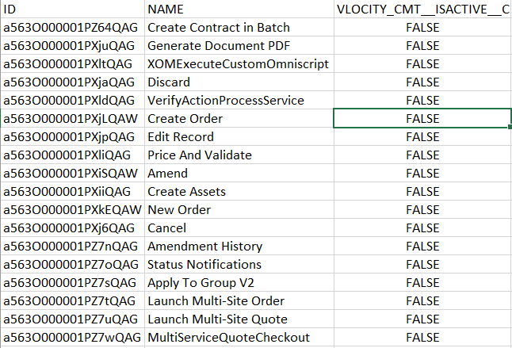

1. Open the Dataloader and Click on **Update**
2. Select the object as “**Vlocity Action(vlocity_cmt__VlocityAction_c)”** and browse the sheet where the “VLOCITY_CMT__ISACTIVE__C” values are updated in the Step 8 and click on “Next”.

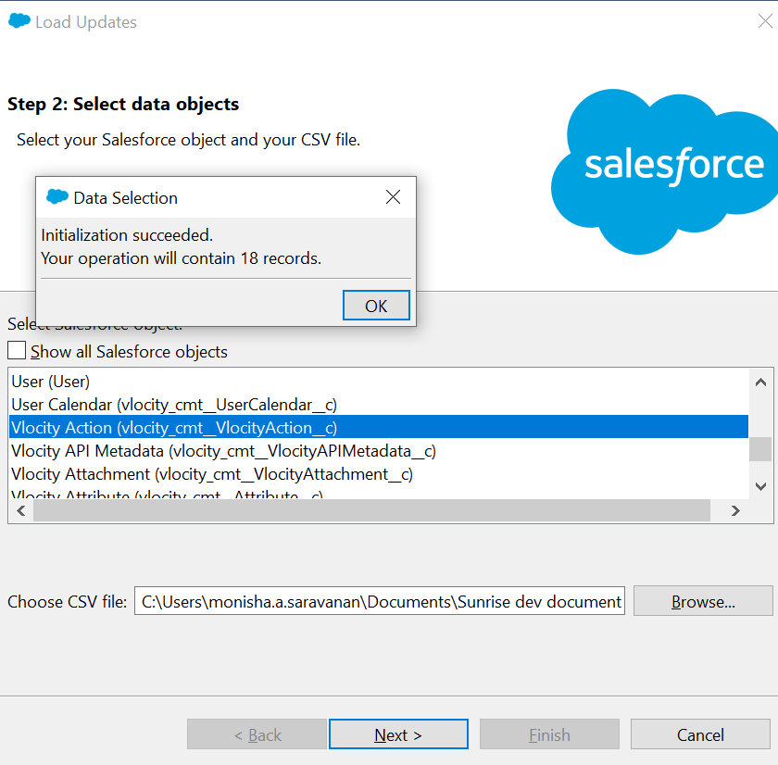

1. Click on Ok and Click “Create or Edit Map”. Then click “Auto Match fields to Columns” and click “Ok”.

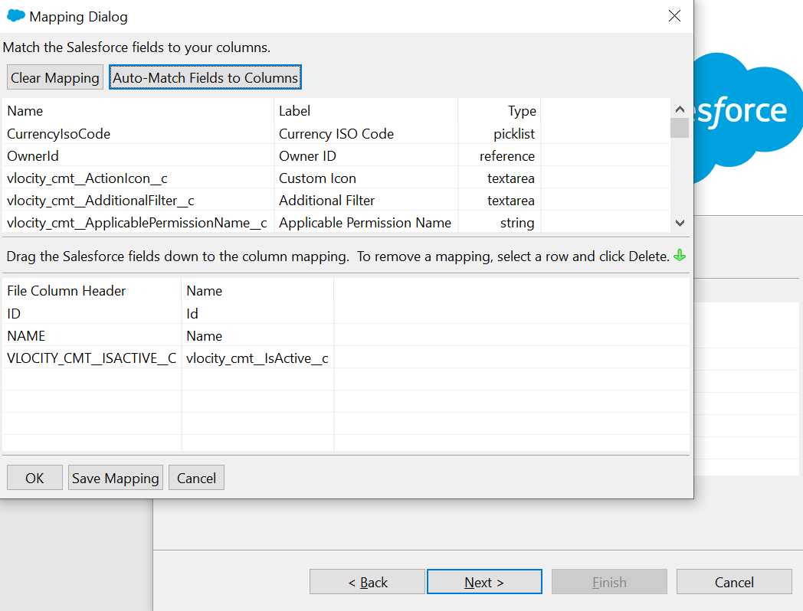

1. After mapping, Click on “Next”.

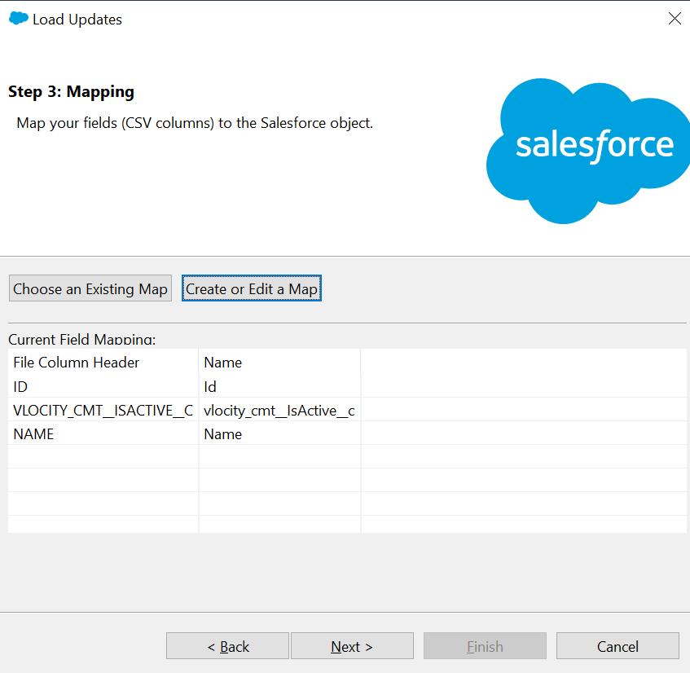

1. Next Click Finish and Choose Yes.

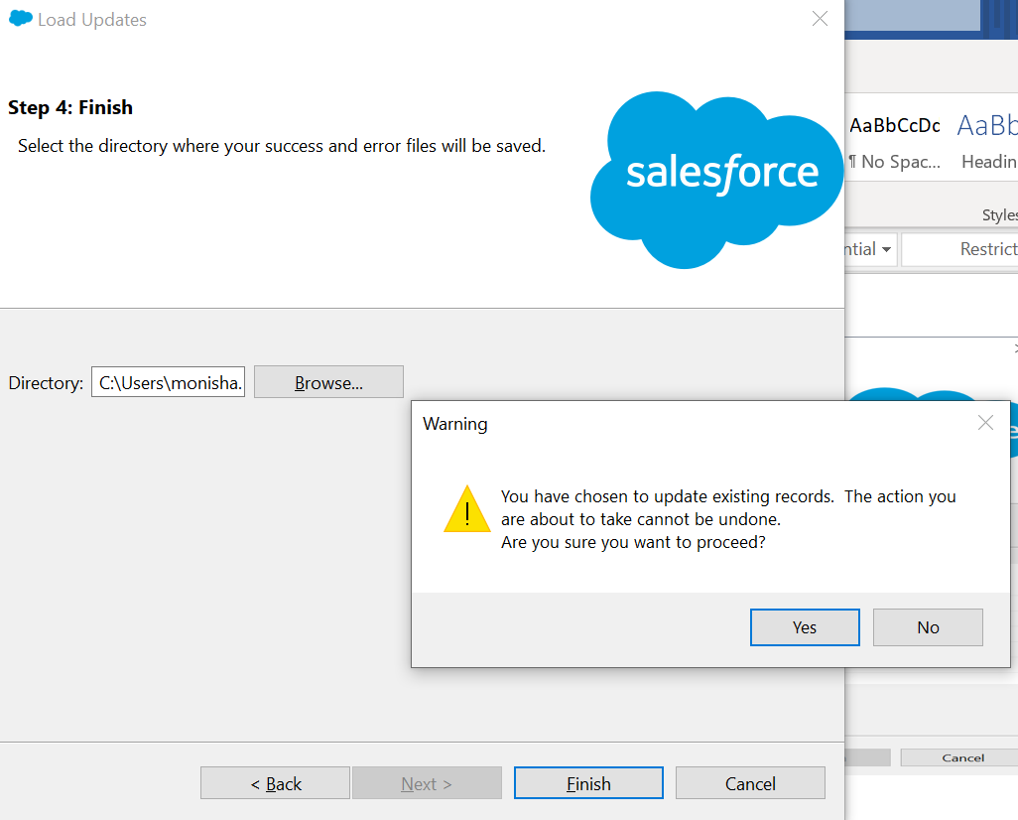

## [2] To Change Display sequence of Vlocity actions:

1. Log in to Salesforce.
2. Click on the App Launcher and search for “**Vlocity Actions**” and click on it.
3. In the List view, Choose “All”.

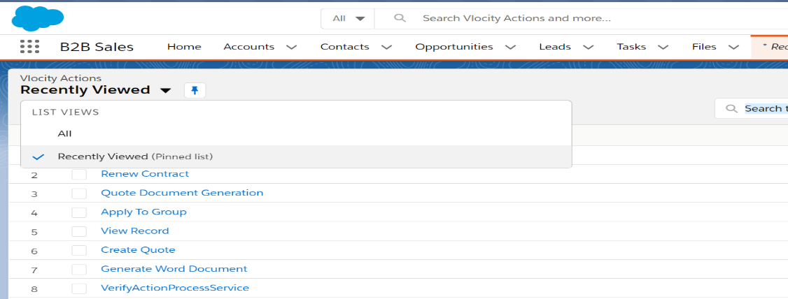

1. In the search box, search for “**Configure**”

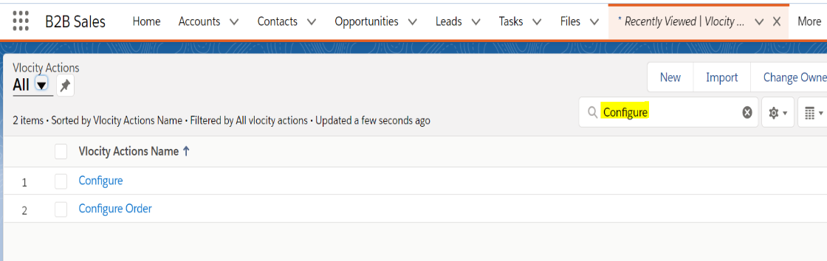

1. Open the “**Configure**” detail page. Edit the “**Display Sequence**” field and update the values as ‘1’ and click on Save.

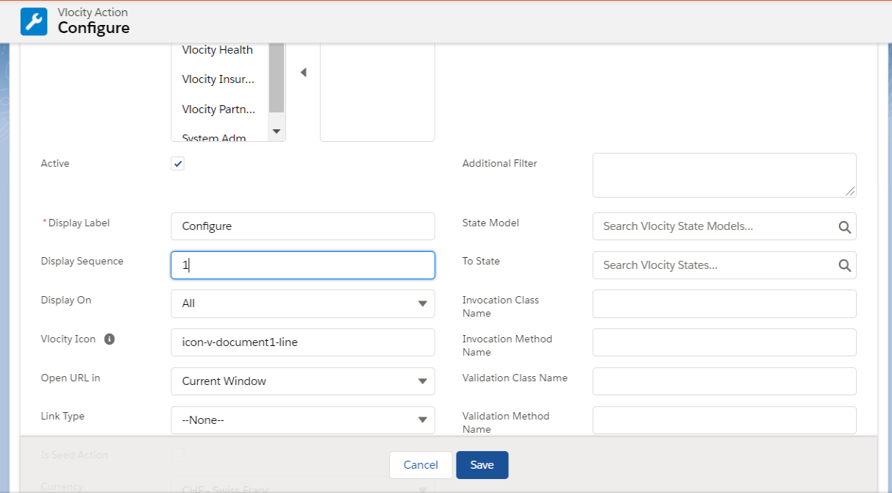

1. Go back to List view “All” and Search for “Create Quote”.
2. Open the “**Create Quote**” detail page. Edit the “Display Sequence” and update the values as ’4’ and click on Save.
3. Go back to List view “All” and Search for “Generate Word Document”.
4. Open the “**Generate Word Document**” detail page. Edit the “Display Sequence” and update the values as ’3’ and click on Save.
5. Go back to List view “All” and Search for “View Record”.
6. Open the “**View Record**” detail page. Edit the “Display Sequence” and update the values as ’1’ and click on Save.